 | IEP & RDA Compliance | CORE NEWSLETTER February 2021
Progress reporting  Progress reporting on annual goals is an important requirement of the IEP process. This reporting allows the teachers and therapists to inform parents about how their child is doing. It is also a wonderful piece of data to use when looking at future needs for evaluation, changes in services or changes in intervention techniques and curriculum.  Here are a few tips for making progress reporting pertinent and usable.  Example:  Annual Goal: When given a list of twenty words containing vowel blends, Joseph will read them within 2 minutes with no more than 2 errors during 3 out of sessions.  - Collect data on annual goals which will allow for progress reporting.  Example: Teacher or para should be recording responses on at least a weekly basis for correct reading of the vowel team words being worked on.  - Use the criteria in your annual goal to determine the type of data to report in your progress goal.  Example:  Progress: Joseph is able to decode words with the vowel blends of ee, ea with 100% accuracy. Vowel teams of ai and ay with 70% accuracy. The next vowel teams will work on are ie, ew and aw.  - .Attach data charts to progress reports.  - Use parent friendly language and explain any strategies or techniques parents may be able to use at home to assist with skill acquisition.  IEPQ has some wonderful resources and much better examples that can also assist with progress reporting. If you do not have an account to IEPQ contact Brandi Gerry at brandi.gerry@state.sd.us.  There are also many examples of data collection sheets which are helpful: teachers pay teachers, chart dog, intervention central are just a few. All of these have examples of data sheets you may find useful.  GRADUATION  A recent article has spurred many questions about graduation and students on an IEP. Below are a few points to remember when addressing questions and determining course requirement for students.  - The majority of students with disabilities on IEP’s should be able to complete the required courses and receive a high school diploma.  - All students who receive a high school diploma must meet the same course requirements. ( These are outlined in the following document https://doe.sd.gov/gradrequirements/)  - Accommodations made to courses are acceptable and would not jeopardize a student’s receipt of a diploma.  - Modifications to a course will result in the ineligibility of the course to count towards graduation requirements.  - Modifications impact the scope of knowledge required by the standards.  DOE has provided a reference for these questions at: https://doe.sd.gov/gradrequirements/documents/DisabilitiesPolicy.pdf  Alternate Assessments  Statewide assessment windows open soon. At this point, no waivers have been approved, so all assessments must be completed. The alternate assessment window will be open March 15 through May 7.  There isn’t a remote option available for assessment at this time. Students who are participating through virtual learning will have to come in to the district to be able to complete the assessment.  The state is still waiting to hear on the waiver for the Alternate Science Assessment, so you should plan to administer at this time. There are several webinars available to assist in delivering the alternate assessment. Current ones can be found on Go sign me up and recordings will be housed on the DOE website. The trainings will not be open until March 1st. |  | Internal file review (IR) date  As part of the changes with the state’s compliance and Results Driven Accountability process, the rubric includes each district conducting individual file reviews. The teachers and therapists are to complete an individual review of one of their own files and then the data from all of the district reviews can be collated to assist the districts in developing a professional development plan. The state will ask each district to report on the district’s completion of the reviews and their professional development plan for the next year. This will happen sometime in May.  The cooperative has scheduled the morning of March 5th for teachers and therapists to come to the cooperative or attend virtually to complete the IR document. This meeting will also include time to review the IEP process and cover any training requirements for those districts who had compliance reviews this year.  Please let Valerie know if there are any specific areas you would like addressed and if you plan to attend via Zoom or in person. The cooperative personnel will do our best to provide for social distancing and will ask all individuals attending in person to please mask  . 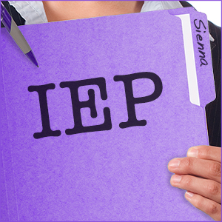  2021 SD Special Education Conference  The 2021 Special Education Conference is scheduled for March 16th and 17th. There are many wonderful presentations on the current agenda including sessions on helping children with mental health issues, RtI, trauma informed practices and literacy.  Please use the following link to register:  Behavior Tips  Adapted from Rebecca Cain’s presentation.  How To Teach Behavior Expectations  - Be sure to teach and practice appropriate behavior in the setting where it is expected. IE: Teach playground rules and behavior on the playground.  - Create a video of the student’s modeling the appropriate behavior and the teacher modeling the inappropriate behavior.  - Change behavior expectation posters frequently. This will help to draw attention to them and remind you to reteach regularly.  - Enlist students who are struggling to teacher the expected behaviors and be models.  - Plan ahead. If you are aware of certain antecedents which can trigger behavior address them ahead of time and help students plan how to handle the situation and what appropriate responses and behaviors are in each case.  - Make sure students and you are calm and in control before teaching behaviors.  - Use positive statements. Tell students what to do instead of what not to do.
EDUCATIONAL DIAGNOSTICIANS WEEK
March 1st – March 6th
Thank You Renee
January
Erin Sibbel – 6; Tania Witt – 11; Holly Mosterd – 24; Karen Peters – 28

February
Jane Keller – 13; Natalie Wright – 16

March
Catrina Brown – 7; Nicole Palmer - 31
Employee Spotlight - David Kocisko School Psychology Intern
As a School Psychologist Intern in my first year at CORE, I am working in the Mount Vernon, Plankinton, and Wessington Springs School Districts. I currently live in Mitchell with my dog, Zuri.

After completing my bachelor’s degree in Psychology and Sociology, I worked in two different psychiatric Residential Treatment Centers for youths with behavioral difficulties. I was a residential worker for over two years before I decided to return to school to become a school psychologist. Before starting school psychology, I dabbled in the world of substitute teaching and gained a tremendous respect for teachers. I also worked for a major airline which allowed me to briefly travel the world.

I enjoy working with students and educators in efforts to support the social, emotional, and behavioral needs of students in these school districts. Outside of work, I enjoy writing poetry, running with Zuri, practicing Brazilian Jiu-Jitsu and Boxing, and a host of other random hobbies. I am blessed to work with an excellent team of kind and knowledgeable professionals, and it makes my day when I am able to support others in establishing meaningful interpersonal connections. I have learned so much this year, and I am looking forward to next year at CORE!
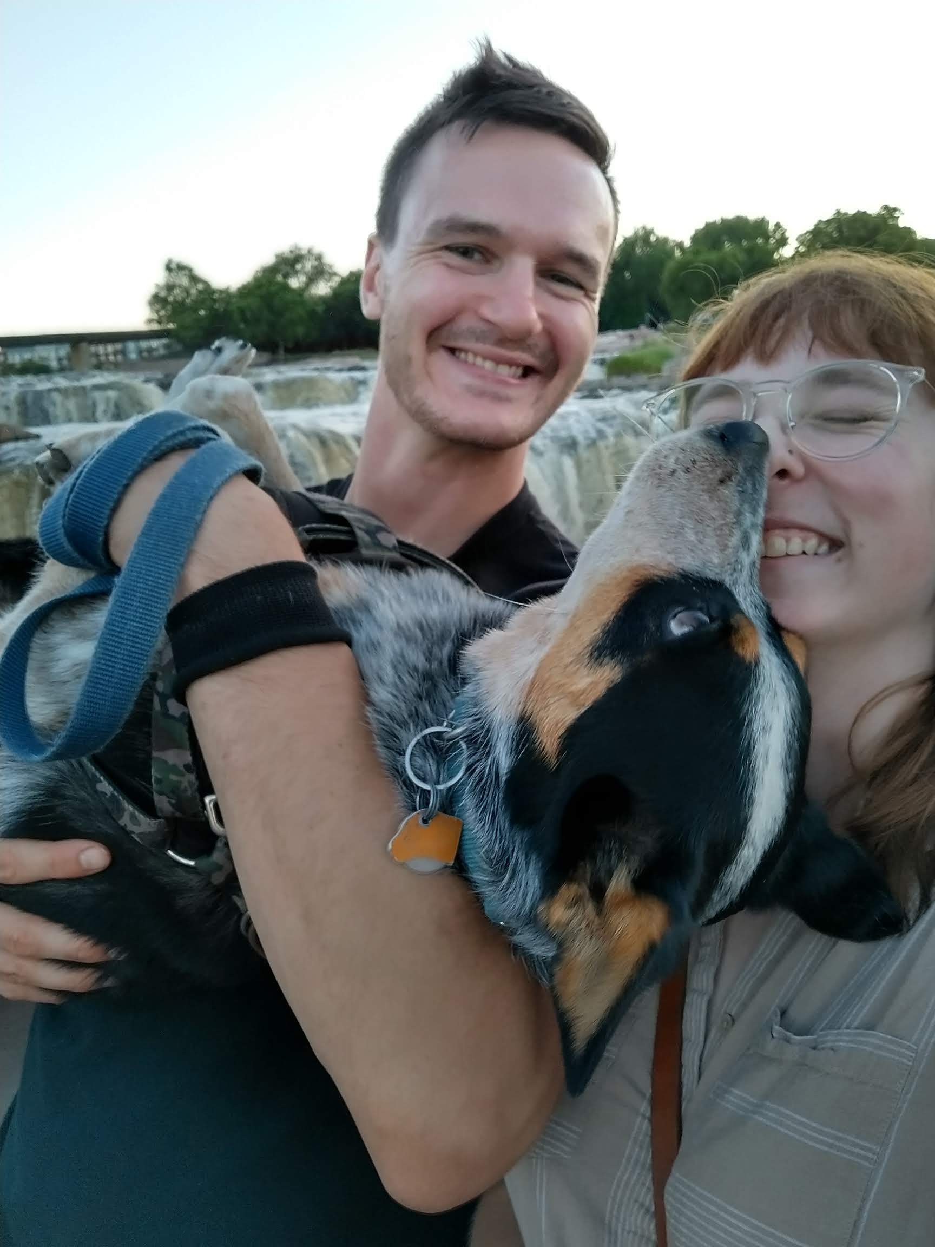
Tell Renee how much we appreciate her.

