Medicaid Procedure
Special Education Teacher’s Responsibilities
1. Ask all parents of children receiving related services if their child is Medicaid eligible.
2. Request consent to bill Medicaid of those who are eligible.
Form is found on Medicaid tab of Sped Advantage.
Documentation of medicaid number and primary provider is very helpful
3. Send copy of signed consent to cooperative. Jane.keller@k12.sd.us
Or upload to sped advantage and email Jane to let he know it has been uploaded.
3. Provide notification to parents annually of district’s continued billing to Medicaid.
This can be done by giving them the notification from Sped Advantage and documenting on the PPWN.
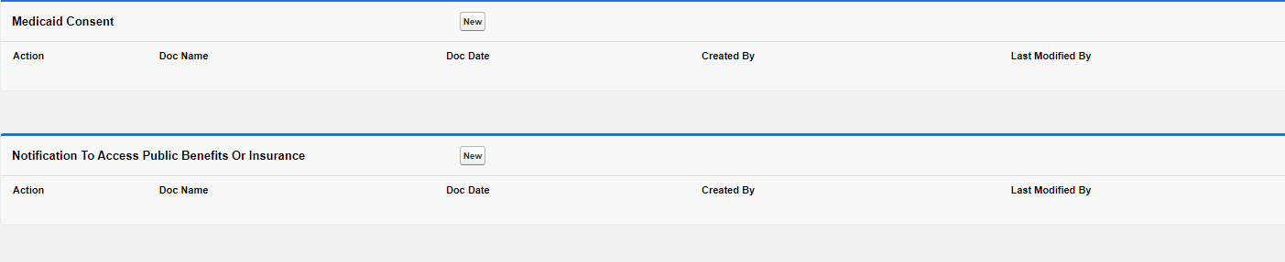

Related Services Responsibilities
1. Work with special education teacher to ensure Medicaid consent is signed, sent to cooperative and annual notification is provided.
2. Keep your NPI information up to date on the Medicaid Portal
You will need to keep your contact information and any new licensure updated.
3. Send logs and notes to cooperative on at least a monthly basis. Jane.keller@k12.sd.us

